

Senior Design Project
Design of Facial Recognition Access Control System

ENGE477 Senior Design Project II
Department of Engineering and Aviation Sciences
University of Maryland, Eastern Shore

Samuel Adedeji

Project Advisor, Dr. Lei Zhang

Submitted
Mon. Day, Year

- Special notice for formatting:
- Don’t add any blank rows. Use spacing or page breaks.
- Every figure or picture inserted in the text, must be accompanied with the caption and detailed description.
- Keep the formatting consistent (learn and apply the MS ‘Styles’ in formatting).
- The final report didn’t meet the basic formatting requirements won’t be accepted.

List of Contents
List of Contents 3
List of Figures 5
List of Tables 5
Abstract 7
1. Introduction 8
1.1 Backgound/Motivation 8
1.2 Objective 8
1.3 Design Requirements 8
1.4 Design Constraints 8
1.5 Design Methods 9
2. Project Description 10
2.1 System Description 10
2.2 System Diagram 10
2.3 System Functions 11
3. Implementation Plan 29
3.1 Tasks 29
3.2 Team Organization 30
3.2.1 Responsibility of Samuel Adedeji. 30
3.3 Timeline/Milestones/Delivery Plan 30
4. Implementation 32
4.1 Implementation of Task 1. 32
5. Conclusion. 32
Acknowledgement 33
Appendix 34
A. Component Specs 34
1. Rapsberry Pi Specifications 34
2. Specs of Arduino 34
REFERENCES 34

List of Figures
Figure 1 General Software Interaction System Diagram 10
Figure 2. General Physical Hardware System Diagram 11
Figure 3. Full State Diagram for Facial Recognition Access Control System 22

List of Tables
Table 1. Project Timeline and Delivery Plan 26

Abstract
- By the end of the project, summarize the project into short text and put here.

- Introduction
- The purpose of this project is to develop a facial recognition door access system for regular homes and home automation applications.

Backgound/Motivation
The development of this facial recognition door access system was inspired by the need of building a more advanced security feature for homeowners in this digital age. Traditional methods of opening a door or allowing visitors into a household are at a disadvantage to the system being developed because they have a longer operating time. When it comes to opening a door with a keys there is a hassle finding the right one placing it into the key lock and turning the lock to unlock it. In addition, traditional door lock are pickable by possible intruders. These are some of the disadvantages of traditional doors systems. The new, smart system being developed will resolve these and other issues. The facial recognition door access system is responsive in the matter of seconds when operated.

Objective
Create a door security system that allows household occupants entry into their house through the usage of a camera and facial recognition algorithm.

Design Requirements
- The design requirements for this project are stated as follows.
- Design and develop a facial recognition algorithm that identifies whitelisted face allowed to enter the household
- Take a picture of the user(person) outside the door on the push of a button
- Add the images of people who are whitelisted for access into the house into a database.
- Compare the image of the individual outside the door to see whether or not he or she matches any of the facial images in the whitelisted database. If the facial image of the person outdoors does match a facial image of a person in the whitelisted database, unlock the door and allow them to access the inside of the house, otherwise keep the door locked.
- An administrative user should be able to remotely unlock the door through the use of internet services and the raspberry pi.
- Users will be allowed the usage of a pin access code outside the door in the case of lost, stolen or misplaced keys.
- Email the picture of the individual(s) that approach the door from outside to the administrative user email as a log of who has recently come to the door.
- Send an MMS alert to the administrative user that someone approached the door and tried to access the inside of the house
- The system must provide an interface to add and remove up to 10 users as authorized or whitelisted user allowed entry into the house.

Design Constraints
- The design constraints for this project are stated as followed:
- Access to wireless network required
- Notification system limited by services available online
- Online services may charge a fee to access or use information
- Computing capability of Raspberry pi limited
- MMS number required
- Email account required
- The budget of this project should not exceed $200

Design Methods
The design methods for this project are described as follows:

The first step for developing this project is to identify a problem that is affecting many people in their daily lives and research possible methods for implementing a solution. The second step is to use the systematic approach of the engineering design process to specify appropriate design requirements and constraints. The third step is to finalize an implementation plan and then gather project specific materials and resources such as the hardware and software that will be used to create the system. The fourth step is to develop a fully operational version of the system through the execution of the implementation plan by completing tasks and subtasks. The final step of developing this project is to modify and make any necessary adjustments to produce the final version of the product.

- Project Description

System Description
The system description for this project is defined as follows:
The user(s) walks up to the front of the door and presses a button besides the door to get a picture of their face taken. This facial image will be a reference image for facial comparison later in the facial recognition process. The picture of the user’s face gets saved onto the raspberry pi locally into a folder and gets sent to Amazon Bucket into a folder associated with the user inside of the Amazon Bucket. Folder gets created in Amazon Bucket invoked by the script from Raspberry Pi using Amazon Rekognition API web services. The facial image is sent to Amazon Rekognition API webservices for facial analysis with another image being retrieve from the MySQL database. For each time the user starts or access the system from outside the door, his or her facial image is compared with the facial images from the pre-existing database in a 1:1 comparison to see whether there is a match between the two faces and whether the matching faces have a similarity score of 85% percent or better between the reference image and image retrieved from the database. The same comparison process is repeated for the remaining images in the MySQL database to determine whether the reference images results in a match in the database. If the facial images match, then that determines the user is allowed access into the house thereby turning on the green led and unlocking the door to allow the person inside the house. Else if the picture does not match one or more the pictures in the databases, the user is not allowed access into the household thereby shining the red led and keeping the door locked restricting the unauthorized user from accessing the inside of the house. Once all the prior steps are done an email and mms notification alert are sent to the administrative user’s cellphone or computer via the internet gateway every time the lock opens and closes.

System Diagram

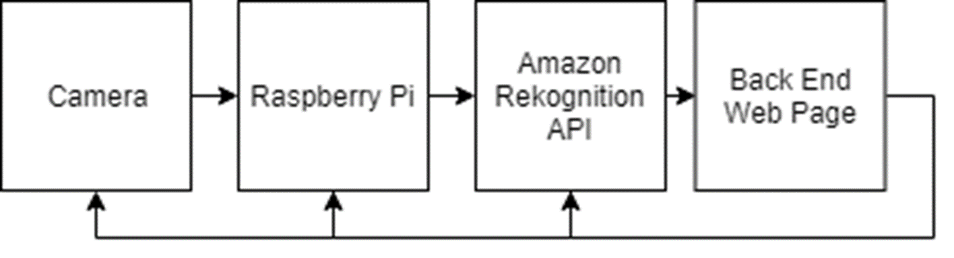
Figure 1 General Software Interaction System Diagram

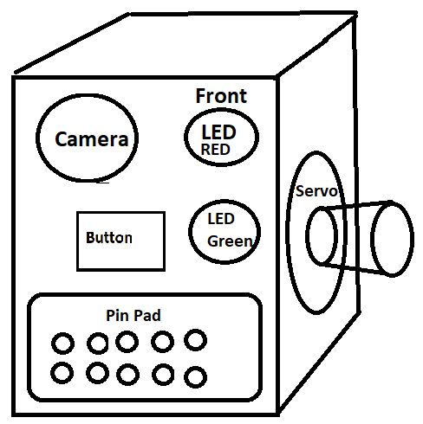
Figure 2. General Physical Hardware System Diagram

System Functions
The designed security system will allow user open door lock with a simple push of a button using basic image recognition or a by typing the correct pin code on the device system. Combining both image recognition and pin code for fall back will provide the best ease of use for any user trying to open the door lock without having to use any keys.

System consists of the following components.

- Raspberry Pi
- Red LED light
- Green LED light
- Breadboard
- Several wires
- Servo Motor
- USB power source (5 volts)
- Camera
- Push button
- Pin Code Key Pad Panel (consisting of multiple buttons)

Basic System Operations and Roles

System Functional Roles

- System will Analyze Image of the User near the door for match (if match happened access granted, LED will turn Green and lock will open, Else will turn Red and lock won’t open)
- System will auto close lock 10 seconds after it’s opened. (timer can be adjusted)
- Grant access to enrolled user using image recognition with a push of a button
- Deny Access to not recognized image of the user
- Grant access to enrolled user using pin code
- Deny access if pin code is incorrect
- Log access (optional) deny and allowed
- Allow admin to allow enrolled User to log into Front End WebPage
- Allow admin to allow enrolled user to remote control lock state
- Allow enrolled user change Pin Code
- Allow enrolled user to change email
- Allow admin to Enroll User
- Allow admin to suspend Enrolled User
- All admin to assign pin code to enrolled user.
- Allow admin to calibrate lock
- Allow admin to take picture of a user
- Allow admin to turn auto-lock close function on or off
- Allow admin to adjust auto-lock close function timer
- Allow admin to calibrate lock
- Allow enrolled user to open or close lock remotely through web page.

How System Works

The way system works is user gets first enrolled into the system. Enrollment gets done by admin who logs into the web page interface, enters user info and takes 3 pictures of a user standing in front of the door lock.

Admin simply adds the user and enters email, first name and password for a particular user, adds the user, at which point user info gets saved into database then and admin requests user to stand in front of the security system camera and clicks on add picture button from front end web page interface, at which point ,the picture of the user would be taken and stored into Raspberry Pi folder named as the username of newly added enrolled user and command would be sent out to Amazon Bucket creating username folder associated with the enrolled user.

Having folder in Amazon Bucket and in RaspberryPi, will allow picture to be stored in both locations. Meaning picture gets stored first into Raspberry Pi locally after picture is being taken then gets sent to Amazon Bucket using either POST Request or through copy of a picture file into username dedicated folder.

Once 3 enrolled user pictures gets sent, across all 3 pictures Amazon Image Recognition Algorithm will be run, analyzing each picture and checking for similarities across all 3 pictures. Meaning it will take for example picture 1 and compare it to picture 2, give it a score of accuracy in percent… then will compare picture 1 to picture 3…. And give it a score of accuracy, then it will take picture 2 and compare it to picture 3 and give it a score of accuracy… thereby giving 3 scores of accuracy.

For example let’s say

Comparison between 1 and 2 received 90%
Comparison between 1 and 3 received 95%
Comparison between 2 and 3 received 86%

Then the total avg score across all 3 pictures would be, 90.3%

Note, that the 3 images taken during enrollment process for the purpose of increasing image accuracy. The reason for that is because conditions change, user may look slightly different, on one picture vs another, depending on the sun light, angle of the user and many other factors, hence in effort to improve accuracy system will require 3 pictures to be taken by the admin of a an enrolled user.

Enrolled User

User is considered enrolled by the admin, when user is added into the front-end interface web page and has 3 enrollment pictures associated with his username and has pin code configured for this particular user.

Suspended User

User is considered suspended as a user who use to be enrolled, but can no longer have access into web portal, and therefore cannot control lock remotely, and therefore wouldn’t have working pin.

Lock State

Lock state is something that is being used to track whether the physical lock is in open position or closed position. Lock state represents 0 for open state, 1 for closed state. Lock state continues to increase to infinity. Lock state flag is what determines whether lock is open or closed. If lock state is odd then lock is closed, if lock state is even than it’s open.

Lock state is stored into a variable, and that variable increases every time lock changes state. Lock can be either changed into either open state or closed state. The state diagram for the lock is provided in diagram below. Any time lock state changes the lock state variable counter goes up by 1.

Lock State Logic Diagram

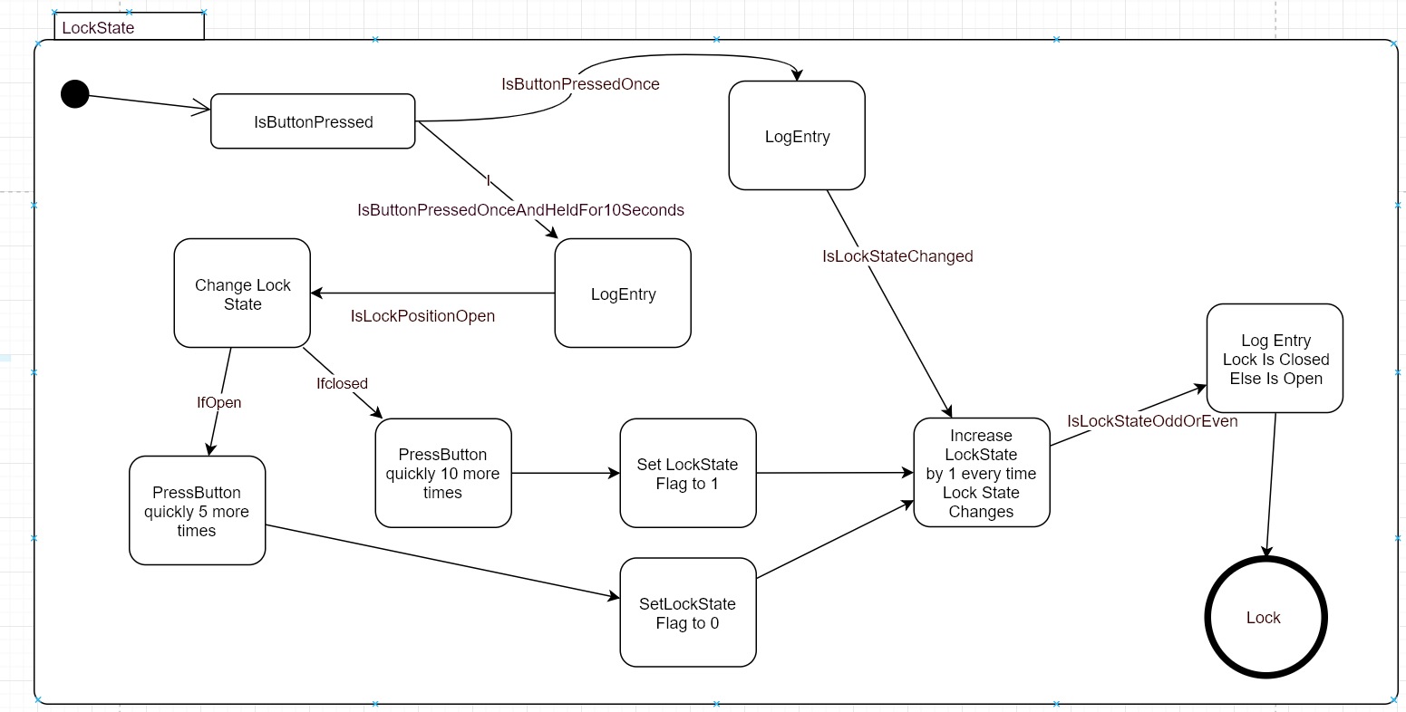

Lock Servo State Diagram

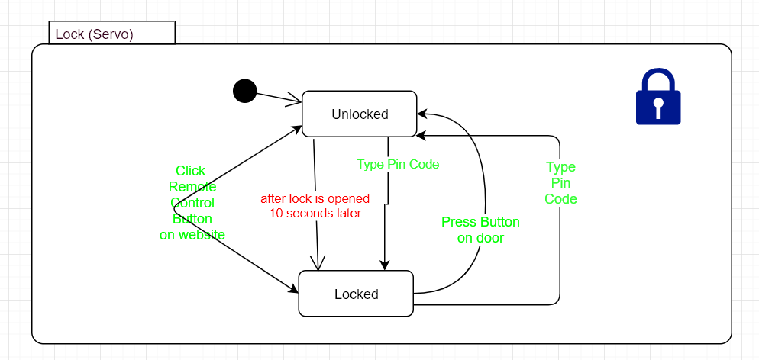

Lock is represented in the image above with 2 states either locked or unlocked, there are 3 ways to lock or unlock, remote control, pin code, push of a button with facial recognition method on security system.

LED State

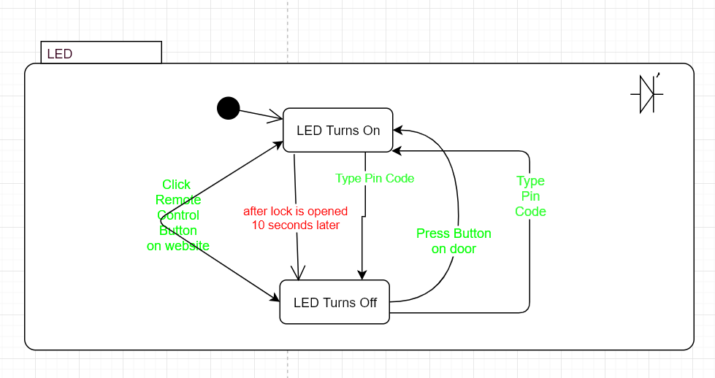
LED state is similar to Servo motor lock state, where it pretty much mimics what lock does, and serves as an indication whether or not access is granted or allowed, it follows 3 grant access use cases, where Green LED light gets turned when button is pushed (Providing that image was recognized after button was pushed), pin code typed (providing pin code matched pin code on record with the particular user accessing the door), or if lock was opened or closed remotely.

Note LED State can either be green or red, depending on which LED is turned on. In the system there are 2 LEDs, one representing granted access with Green LED and one representing Deny Access as Red LED. Depending on whether access was allowed or denied appropriate color will turn up, regardless of which type of access being used.

Camera State
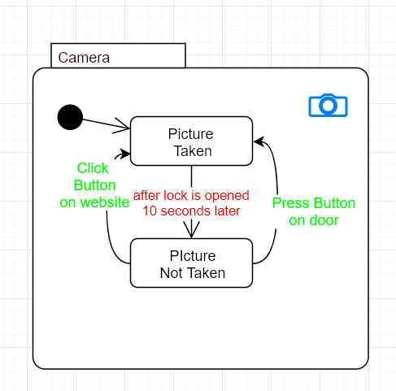

Camera has only 2 states, either picture been taken or not taken. Picture can be taken either from the website remotely or through the push of a button (providing that picture was recognized by Amazon Image Recognition API)

Pin Code State
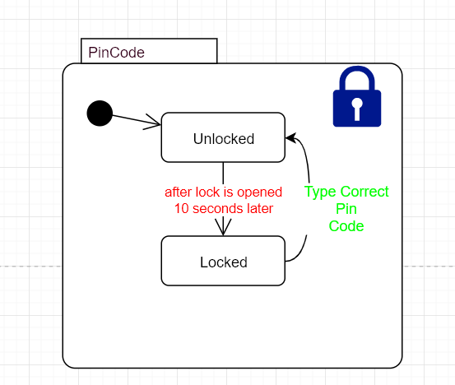

Pin code allows lock to be opened (providing that it’s the correct pin code and matches what’s in the database for an enrolled user.

Granted Access

Type 1 Granted Access using image recognition

Access is considered granted whenever image of a user was recognized by Amazon Recognition API and Servo Motor changed state to open and LED turned green, and lock state flag increase by 1. At which point, access is granted to user temporarily for 10 seconds, after 10 seconds lock would close automatically increasing lock state flag by once again 1, and turning off LED. Else, RED LED would turn on, (lock state flag would not increase), RED LED would turn itself off 10 seconds later, but will not open the lock.

Type 2 Granted Access using pin code

Access is considered type 2 granted if and only if user entered a pin code and pin code entered matched with what is on record inside the Raspberry Pi database, at which point LED would turn Green, lock would open up, lock state flag would increase by 1 and lock would automatically close in 10 seconds if auto-lock function is turned on and once again will increase lock state flag by 1.

Type 3 Granted Access using web page

Access is considered type 3 granted if and only if enrolled user or the admin, changes the lock state remotely. In which case similar process as with Type 1 and Type 2 would happen, where if access is granted, LED would turn green, lock would change state to open position, lock state flag (counter) would go up by 1 and once again lock would close 10 seconds later and once again lock state counter will go up by 1, providing auto lock close function is turned on.

If auto lock close function is turned off, then essentially remote user who is logged in through the web page would be able to either open or close the clock, where lock state change would go up every time lock opens or closes, but there would be no automatic closing of the lock by the system.

Granted access using web page can only be provided through web page, if lock is already closed. However, closing lock is also allowed from the web-page as well, in case if it’s opened and auto lock function was turned off, by default auto lock close function is turned on for better security.

Auto Close Lock Function

By default when access is granted Servo motor will turn itself back to close position after 10 seconds. This function is designed to enhance security in a way when the lock opens after image of the user being recognized and automatically closes itself. Note lock will close itself no matter what regardless if the door is open or closed after 10 seconds.

If that happens user simply need to push the button again for picture to be taken again and for system to recognize the user, at which point lock will re-open itself and the user can shut the door before 10 seconds expire. After 10 seconds expire, lock will close itself. Hence ideally this function is good for situations where user always closed the door 10 seconds after. (timer can be adjusted by the admin)

Enrollment Logic

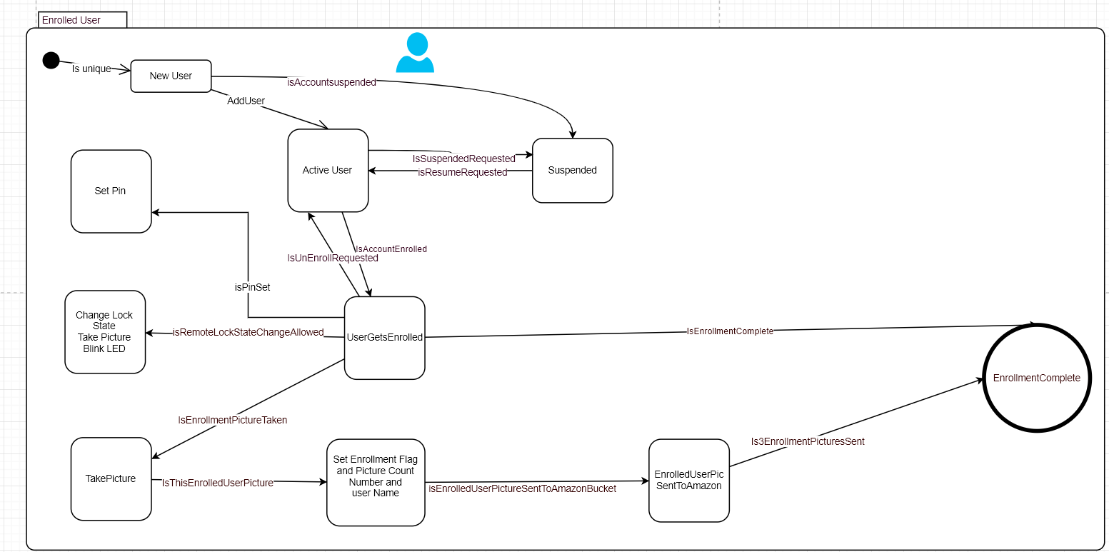

The way enrollment user function works is, user gets added by admin in front end interface, new user information added such including email, phone number, name, and username as well as password. Pin Code is set for the user by the admin, permissions are set for the users, such as allowing user to control remotely lock. Web UI interface will follow logic that would allow admin to suspend or resume the enrolled user.

Enrollment function allows admin to enroll the user into the system, by requesting user to stand in front of the camera, where admin would press the button taking picture of the user 3 consecutive times. During each time picture is taken, it would be stored into database on Raspberry Pi, then sent over to Amazon Bucket dedicated username folder associated with the enrolled user.

Enrollment Pics Sent To Amazon Diagram
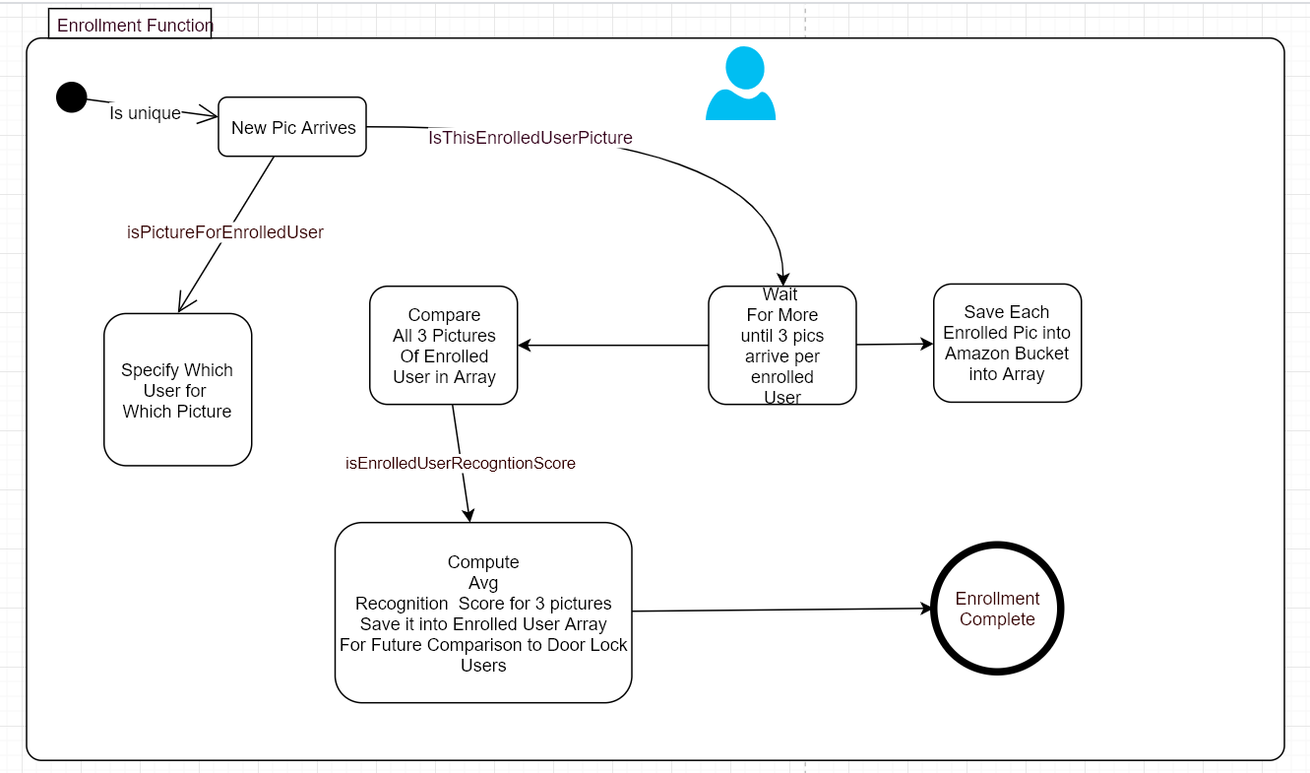

This shows what happens when new picture arrives into Amazon bucket, if the picture happens to be from enrolled user it gets saved into Array after waiting for the total of 3 pictures, at which point recognition score for all 3 images would be computed using Amazon image recognition algorithm. When picture arrives to Amazon bucket it gets placed into a folder associated with the enrolled username.

Door Lock User Pressing Button Logic
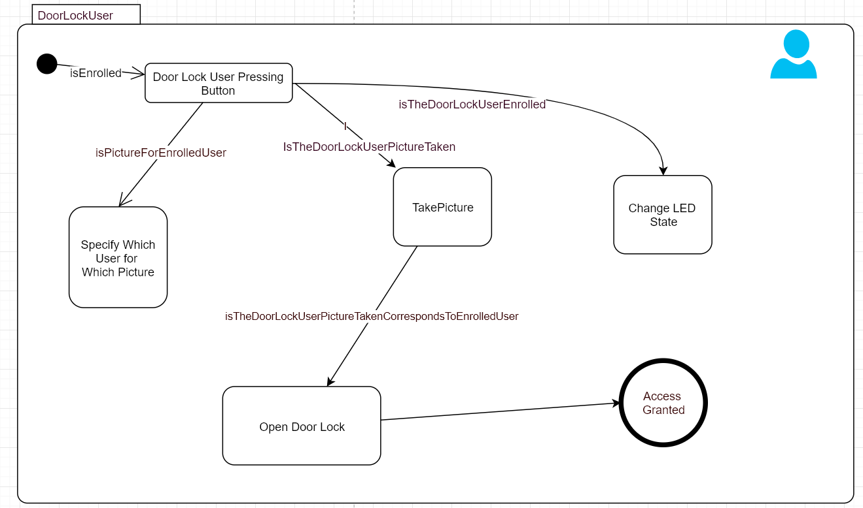

When the button gets pushed picture gets taken, LED light changes state to GREEN, door lock changes state, access gets granted, lock state flag increase by 1. Details for the logic flow are shown in the next diagram (called Detailed System Diagram Logic).

Detailed System Diagram Logic for user who is pushing button and already enrolled.
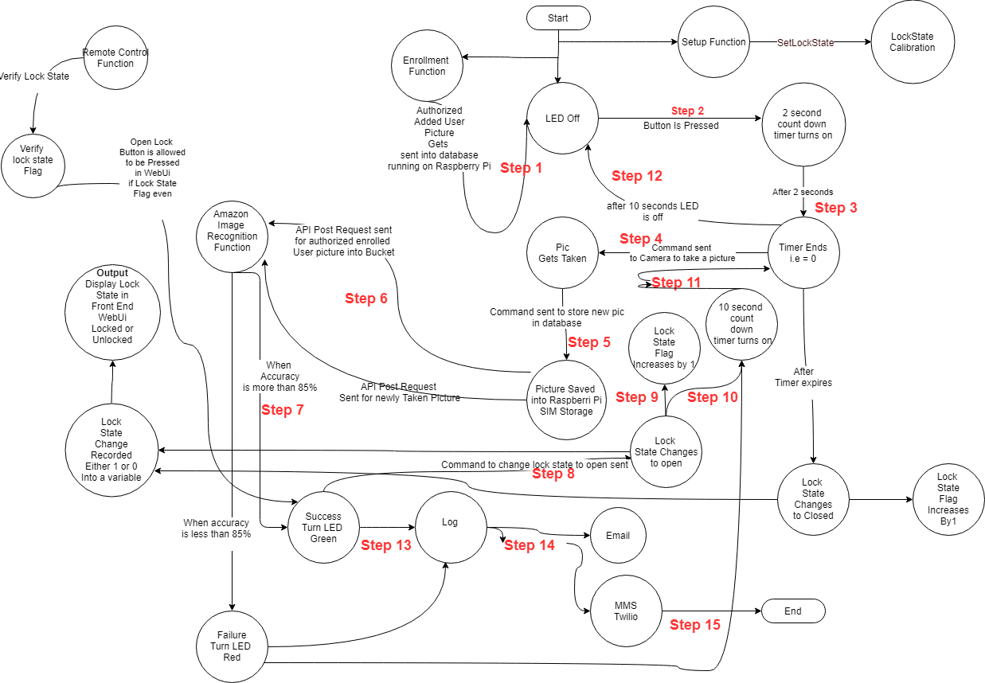
Figure 3. Full State Diagram for Facial Recognition Access Control System

Figure 3 above shows 14 steps of what happens when the user pushes the button and already happen to be enrolled. Along with the following other states of the system:

- Enrolled User Controls Lock Remotely Open Logic Diagram
- Remote user controls lock remotely close Logic Diagram

- When User Fails Image Recognition Logic Diagram

Lock Calibration Logic Diagram
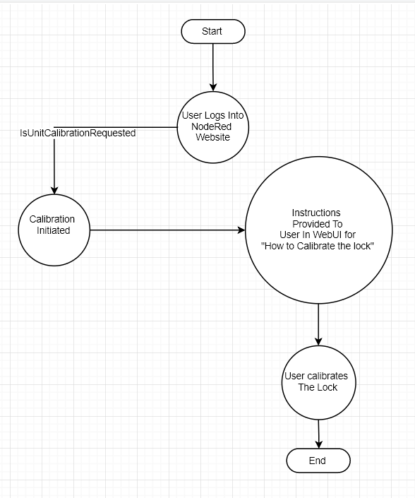

- Lock calibration diagram shows basic logic for calibrating lock and making sure the state of the lock is tracked.

Enrollment Logic Diagram

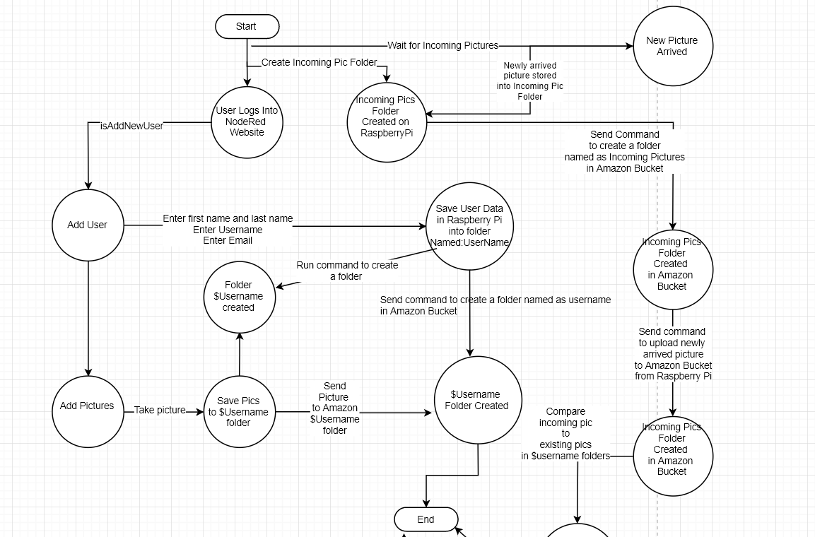
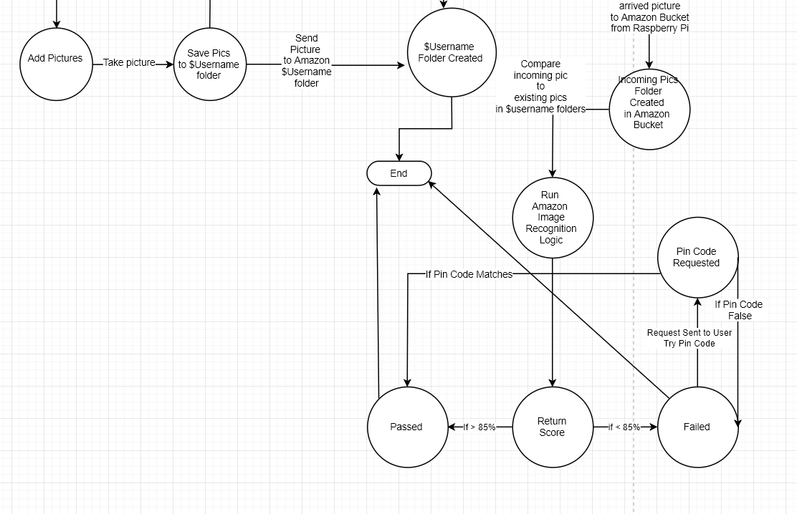

- Implementation Plan

Tasks
- The tasks needed to be accomplished in the project are stated as follows:
- Task 1. Design and develop the door lock, LED, raspberry pi and camera circuit
  - Subtask 1. Setup the complete circuit to visualize the access system that will enable and disable entry into the house based on who is recognized at the front door.
  - Subtask 2. Ensure that the camera and raspberry pi facial recognition module are fully operational and running once power is supplied to the circuit.
  - Subtask 3. Turn the green and red LEDs in the circuit on and off to identify is the door is unlocked or locked respectively.
- Task 2. Design and develop a facial detection algorithm with Amazon Rekognition API.
  - Subtask 1. Create an AWS account.
  - Subtask 2. Create a bucket and upload an image to be analyzed
  - Subtask 3. Use the API command to analyze the image and obtain results
- Task 3. Design and develop a facial recognition algorithm with Amazon Rekognition API
  - Subtask 1. Create an AWS account.
  - Subtask 2. Create a bucket and upload an image that is to be analyzed
  - Subtask 3. Use the API command to analyze the image and obtain results
- Task 4. Design and develop a mySQL database to store and retrieve image files for comparison.
- Subtask 1. Create a mySQL database on a front-end webserver
- Subtask 2. Create the front-end graphical user interface to upload reference images
- Subtask 3. Store multiple reference images into the database
- Task 5. Identify the proper online api to create the email/mms notification system for the administrative user.
  - Subtask 1. Identify twilio as the online API that will be used to carry out the task of notifying the administrative user of the system
  - Subtask 2. Create a Twilio account
  - Subtask 3. Setup and manage Twilio SMS/MMS messaging APIs’
  - Subtask 4. Take a picture of the current user at the door and send the image to the administrative user email account
  - Subtask 5. Create custom message based upon whether or not the most recent user at the door is allowed or disallowed access to the house.

- Team Organization
- All the task and subtasks specified in the last section are to be completed by Samuel Adedeji. The responsibilities of Samuel Adedeji are stated as follows.

Responsibility of Samuel Adedeji.
- Task 1,2,3,4

Timeline/Milestones/Delivery Plan

- Please prospect the timeline to deliver the results of each task/subtask.
- Please schedule your project to no more than 22 weeks from now.
- Project Timeline and Delivery Plan
Time | Task | Comments | Responsible Personnel
Week 1 | Independent Research | Research possible Smart home ideas that would be deemed a good project idea to implement | Samuel Adedeji
Week 2 | Independent Research | Researched and summarized articles on the topic of smart mirror | Samuel Adedeji
Week 3 | Independent Research | Re-identified Facial Recognition Access Control System as a problem that the project development could provide a solution for. | Samuel Adedeji
Week 4 | Independent Research | Researched and summarized articles on the topic of Facial Recognition Access Control System | Samuel Adedeji
Week 5 | Independent Research | Received raspberry pi, camera module and additional hardware that will be used to implement the project tasks | Samuel Adedeji
Week 6 | Independent Research | Initialized the Linux Raspbian operating system OS on the Raspberry Pi 2 to begin implementing tasks | Samuel Adedeji
Week 7 | Task 2 | Setup facial detection of facial images using HTTP post and get request with Amazon’s Rekognition API | Samuel Adedeji
Week 8 |  |  | Samuel Adedeji
Week 9 |  |  | Samuel Adedeji
Week 10 |  |  | Samuel Adedeji
Week 11 |  | Obtained DIP tactile switch, continuous servo motor | Samuel Adedeji
Week 12 |  |  | Samuel Adedeji
Week 13 |  |  | Samuel Adedeji
Week 14 |  |  | Samuel Adedeji
Week 15 |  |  | Samuel Adedeji
- Implementation

Implementation of Task 1.
4.1.1 Subtask 1.
4.2.1

- Conclusion.
- By the end of the project, conclude the project and your learning experience.

Acknowledgement
- If you get help or support from someone else (besides the team member and the advisor) and want to show your appreciation, put here (do not include the advisor).

Appendix
- You can put reference info here, including:
- specs of components used in the system,
- source code (must be here but not in the body text), iii) CAD figures, etc.
- Component Specs
- Rapsberry Pi Specifications
- The Raspberry Pi 2 Model B is the second-generation Raspberry Pi. It replaced the original Raspberry Pi 1 Model B+ in February 2015. It includes:
- A 900MHz quad-core ARM Cortex-A7 CPU
- 1GB RAM
- 4 USB ports
- 40 GPIO pins
- Full HDMI port
- Ethernet port
- Combined 3.5mm audio jack and composite video
- Camera interface (CSI)
- Display interface (DSI)
- Micro SD card slot
- Video Core IV 3D graphics core
- Because it has an ARMv7 processor, it can run the full range of ARM GNU/Linux distributions, including Snappy Ubuntu Core, as well as Microsoft Windows 10. The Raspberry Pi 2 has an identical form factor to the previous (Pi 1) Model B+ and has complete compatibility with Raspberry Pi 1.

- Specs of Arduino

REFERENCES
[1] Gigli, M., & Koo, S. (2011, July). Internet of Things: Services and Applications Categorization. Retrieved January 28, 2016, from http://file.scirp.org/pdf/AIT20110200005_90413785.pdf

[2] Bojanova, I. (2015, March 31). What Makes Up the Internet of Things? Retrieved December 28, 2016, from https://www.computer.org/web/sensing-iot/content?g=53926943&type=article&urlTitle=what-are-the-components-of-iot-

[3] Gubbi, J., Buyya, R., Marusic, S., & Palaniswami, M. (n.d.). Internet of Things (IoT): A Vision, Architectural Elements, and Future Directions. Retrieved January 13, from https://arxiv.org/ftp/arxiv/papers/1207/1207.0203.pdf

[4] Lu, J., & Sookoor, T. (n.d.). The Smart Thermostat: Using Occupancy Sensors to Save Energy in Homes. Retrieved January 8, 2017, from http://www.alice.virginia.edu/~stankovic/psfiles/sensys10-final169.pdf

